

**Beryl8 Summary**

**By**

**Mr. Wasin Heesawat 6288077**

**Ms. Intr-orn Lertsupakitsin 6288089**

**Mr. Krissanapong Palakham 6288102**

**Mr. Pongsakorn Piboonpongpun 6288107**

**Presented to**

**Asst. Prof. Dr. Srisupa Palakvangsa Na Ayudhya**

**A Report Submitted in Partial Fulfillment of**

**the Requirements for**

**ITCS495 Special Topics in Database and Intelligent Systems**

**Faculty of Information and Communication Technology**

**Mahidol University**

**Semester 1/2022**

Table of Contents

Introduction of Digital Transformation 3

Digital Transformation in Practice 4

Project Implementation Approach 5

Project structure 6

**Be 8 - Summary**

Beryl8 is a consulting company that focuses on digital transformation to all clients which delivered 250 projects.

# Introduction of Digital Transformation

1. **Why digitally transform?**

* The already established corporate environment has undergone significant and continuous paradigm transformations as a result of the internet, cloud computing, and social media. Business cost structures become more accessible due to new technology, enabling small enterprises to start markets more efficiently.
* 3 degrees of innovation
  + Making digital information accessible and available (from analog to digital) is the process of digitization.
  + Digitalization is the practice of using technology to automate tasks.
  + The process of creating new business applications that integrate all digitized data and apps for new innovation is known as digital transformation.

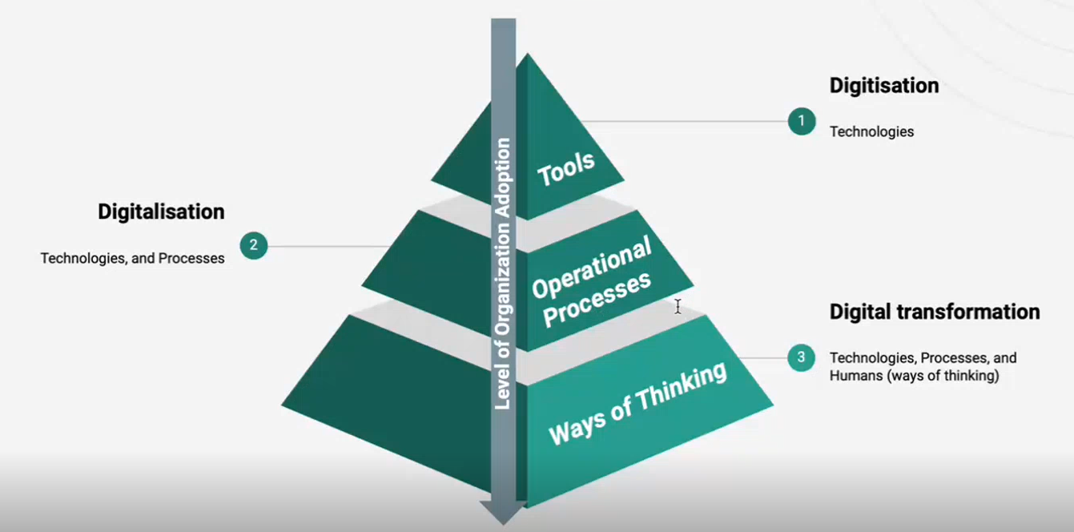

Figure 1: A level of organization adoption

1. **Strategies a digital transformation**

* #1: Define a Strategy: Companies must determine which digital channels are most relevant to their customers and business in order to map them to their business goals and establish a strategy spot. For example: What is your product? / What is the channel to distribute the product? / How do you communicate this product to your customers? (Focus on channel, media, target group)
* #2: Develop a Personalized Experience: Companies must shift their attention from looking at consumers in aggregate to beginning to build experiences and interventions at the personal level by providing employees with tools and training.
* #3: Streamline Technology & Processes: Companies must break down the silos of well-established infrastructure and immediately interact with others to ensure that every individual effort is related to your strategic purpose.

# Digital Transformation in Practice

* **Digital transformation in retails**: charting a strategy through digital disruption to achieve customer service excellence.
  + Technology Driving Forces: Cloud, Mobile, Social, and Data Science
  + Customer Centric Approach: Connected Customer, Connected Channel, Connected Journey, and Connected Operations
* **Digital transformation in airlines**: navigating digital disruption to achieve customer service excellence.
  + Customer Centric Approach: Connected Customer, Connected Channel, Connected Journey, and Connected Operations
  + Technology Driving Forces: Cloud, Social, Mobile, and Big Data
* **Digital transformation in petrochemicals**: managing digital disruption to achieve corporate operations and customer service excellence.
  + Technology Driving Forces: Cloud, Mobile, Social & Community, and Data Science
  + Driving Strategies: Digitization, Synchronization & Collaboration, Planning & Analytics Mindset, and Conversion

# Project Implementation Approach

* **Project phases and approach**

1. **Analysis** – Focus on where the consulting business user come together, talk about what the system looks like, and what the functionality is.
2. **Design** – The business consulting team deconstructs the business requirements and incorporates them into the design specification (blueprint). E.g., What should be done to improve the system? What actions should be taken on the platform? What should be configured into the tools we use?
3. **Development** – Build the system according to the design specification that emerge throughout the design phases and perform the UNIT test.
4. **Test** – They are testing the application with a test script, and the test result should be "pass."
   1. SIT: test if several systems interact appropriately
   2. UAT: real user testing of the system to ensure that what has been given is acceptable.
5. **Deploy & Maintenance** – When the user tests the system and finds that everything works well, the system can be deployed.

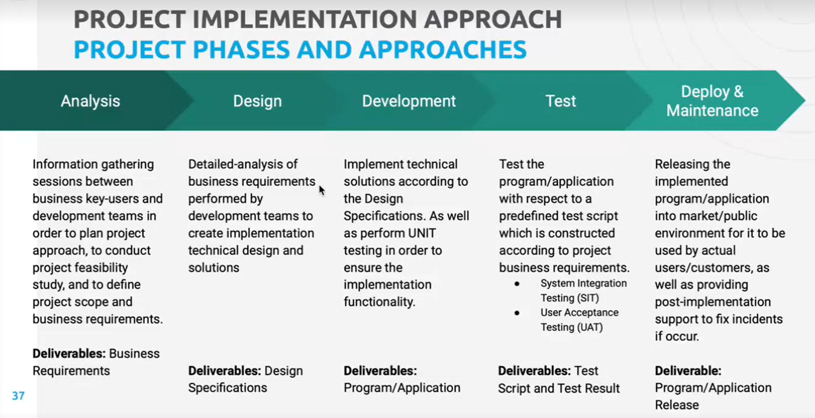

Figure 2: The project implementation approaches

**“Waterfall”**

* + pros: Simplicity, Because of the rigidity of the model, it is simple to manage and control.
  + cons: Lack of adaptability and sparse communication during some project phases

**“Agile”**

* pros: Flexibility, Teams in charge of business and deployment communicate constantly
* cons: Overruns in resources and timelines, complex management

# Project structure

* project members, responsibilities & required Skill Sets

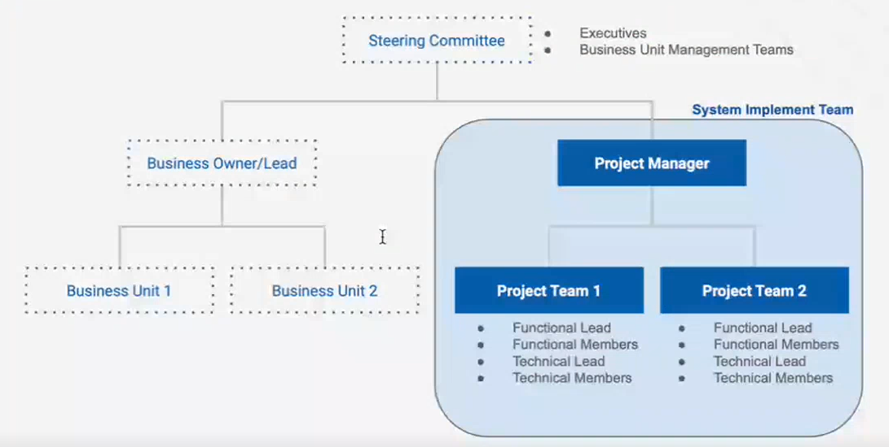

Figure 3: Project structure chart

According to Figure 3, there are represented the project structure that will be focused on a system implement team. The project manager, who is the leader of the project, and two other project teams are members of the system implementation team.. Each project team includes a functional lead, functional members, technical lead, and technical members. Two project teams contains the same of team members.